

**Research Coordination System**

**Submitted by**

Md Sabbir Ahammed

171-35-1979

Department of Software Engineering

Daffodil International University

**Supervised by**

Nusrat Jahan

Senior Lecturer

Department of Software Engineering

Daffodil International University

This Project report has been submitted in fulfillment of the requirements for the Degree of Bachelor of Science in Software Engineering.

© All right Reserved by Daffodil International University

**Approval**

This thesis titled on “**Research Coordination System**”, submitted by Sabbir Ahammed (ID:171-35-1979) to the Department of Software Engineering, Daffodil International University has been accepted as satisfactory for the partial fulfillment of the requirements for the degree of Bachelor of Science in Software Engineering and approval as to its style and contents.

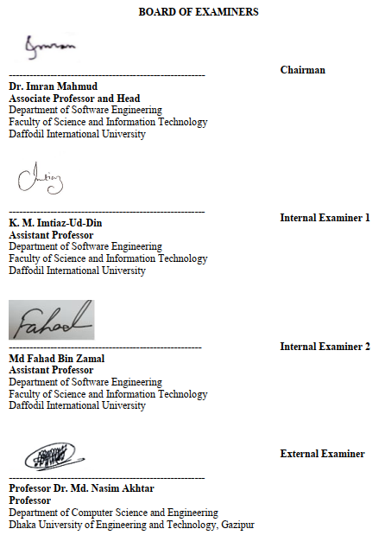

**Declaration**

The project entitled “**Research Coordination System**” is done under the supervision **Ms. Nusrat Jahan** Senior Lecturer, Department of Software Engineering, Daffodil International University. I declare that this project is my original work for the degree of B.Sc. in Software Engineering and that neither the whole work nor any part has been submitted for another degree in this or any other university.

|  |  |
| --- | --- |
|  | Certified by |
| **---------------------------------------------** | **---------------------------------------------** |
| **Sabbir Ahammed**  **ID: 171-35-1979**  **Batch: 22th** | **Ms. Nusrat Jahan**  Senior Lecturer |
| Department of Software Engineering  Faculty of Science & Information Technology  Daffodil International University | Department of Software Engineering  Faculty of Science & Information Technology  Daffodil International University |

**Acknowledgement**

At first, I express my heartiest thanks and gratefulness to almighty Allah for divine blessing made it possible to complete this project successfully. I feel grateful to Nusrat Jahan, senior Lecturer, Department of Software Engineering, Daffodil International University. Deep knowledge keen interest of my supervisor in the field of technology influenced me to carry out this project. His endless patience, scholarly guidance, continual encouragement, constant and energetic supervision, constructive criticism, valuable advice, reading many inferior drafts and correcting them at all stage have made it possible to complete this report. I would like to express my heartiest gratitude to Dr. Imran Mahmud, Head of the department, Department of SWE, Daffodil International University, for his kind help to finish my project and to other faculty member and all other staffs. Finally, I must acknowledge with due respect the constant support and patience of my family.

**Table of Content**

|  |  |
| --- | --- |
|  |  |
| Approval | ii |
| Declaration | iii |
| Acknowledgement | iv |
|  |  |
| 1. **Introduction** | 1 |
| * 1. Project Overview | 1 |
| * 1. Project Purpose | 1 |
| * + 1. Background | 1 |
| * + 1. Benefits & Beneficiaries | 2 |
| * 1. Stakeholders | 2 |
| * 1. Proposed System Model | 3 |
| * 1. Project Schedule | 4 |
| * + 1. Gantt Chart | 4 |
| * + 1. Release Plane/Milestone | 4 |
| 1. **Software Requirement Specification** |  |
| * 1. Functional Requirements | 5 |
| * + 1. Log In | 5 |
| * + 1. Update Profile | 5 |
| * + 1. Register New User | 5 |
| * + 1. Assign Coordinator | 5 |
| * + 1. Assign Task | 6 |
| * + 1. Submit Paper Details | 6 |
| * + 1. Report Writing | 6 |
| * + 1. Log Out | 6 |
| * 1. Performance Requirements | 7 |
| * + 1. Speed and Latency Requirements | 7 |
| * + 1. Precision or Accuracy Requirements | 7 |
| * + 1. Capacity Requirements | 7 |
| * 1. Dependability Requirements | 7 |
| * + 1. Reliability Requirements | 7 |
| * + 1. Availability Requirements | 8 |
| * + 1. Robustness or Fault-Tolerance Requirements | 8 |
| * + 1. Safety-Critical Requirements | 8 |
| * 1. Security Requirements | 8 |
| * + 1. Access Requirements | 9 |
| * + 1. Integrity Requirements | 9 |
| * + 1. Privacy Requirements | 9 |
| * 1. Usability and Human-Interaction Requirements | 9 |
| * + 1. Personalization and Internationalization Requirements | 9 |
| * + 1. Understandability and Politeness Requirements | 9 |
| * + 1. Accessibility Requirements | 9 |
| * + 1. User Documentation Requirements | 9 |
| * + 1. Training Requirements | 10 |
| * 1. Look and Feel Requirements | 10 |
| * + 1. Appearance Requirements | 10 |
| * + 1. Style Requirements | 10 |
| * 1. Operational and Environmental Requirements | 10 |
| * 1. Legal Requirements | 10 |
| 1. **System Analysis** |  |
| * 1. Use Case Diagram | 11 |
| * 1. Use Case Description | 12 |
| * 1. Activity Diagram | 23 |
| * 1. System Sequence Diagram | 34 |
| 1. **System Design Specification** |  |
| * 1. Class Responsibilities Collaboration | 41 |
| * 1. Class Diagram | 42 |
| * 1. Database Design Diagram | 43 |
| * 1. Development Tools & Technology | 43 |
| 1. **System Testing** |  |
| * 1. Testing Features | 45 |
| * + 1. Features to be Tested | 45 |
| * 1. Testing Strategies | 45 |
| * + 1. Unit Testing | 45 |
| 1. **User Manual** |  |
| * 1. User Manual (Admin) | 47 |
| * 1. User Manual (Coordinator) | 49 |
| * 1. User Manual (Faculty) | 51 |
| 1. **Project Summary** |  |
| * 1. GitHub Link | 53 |
| * 1. Limitations | 53 |
| * 1. Future Scope | 53 |
| 1. **References** | 54 |
| * 1. Documentation Idea | 54 |
| * 1. System Requirement Specification | 54 |
| * 1. Structure and Architecture | 54 |
| * 1. Unified Modeling Language | 54 |
| * 1. Testing | 54 |
| * 1. Tools and technologies | 54 |
|  |  |

**List of Figures**

|  |  |  |
| --- | --- | --- |
| 1.1 | Block Diagram | 3 |
| 1.2 | Release Plan/Milestone | 4 |
| 3.2 | Use Case Diagram | 11 |
| 3.2 | Activity Diagram (Log In) | 23 |
| 3.3 | Activity Diagram (Manage Profile) | 24 |
| 3.4 | Activity Diagram (Assign Coordinator) | 25 |
| 3.5 | Activity Diagram (Register New Faculty) | 26 |
| 3.6 | Activity Diagram (Assign Task) | 27 |
| 3.7 | Activity Diagram (View Task) | 28 |
| 3.8 | Activity Diagram (Submit Task) | 29 |
| 3.9 | Activity Diagram (Notification) | 30 |
| 3.10 | Activity Diagram (Report Writing) | 31 |
| 3.11 | Activity Diagram (Paper Details) | 32 |
| 3.12 | Activity Diagram (Log Out) | 33 |
| 3.13 | Sequence Diagram (Log In) | 34 |
| 3.14 | Sequence Diagram (Manage Profile) | 35 |
| 3.15 | Sequence Diagram (Assign Coordinator) | 36 |
| 3.16 | Sequence Diagram (Register New User) | 36 |
| 3.17 | Sequence Diagram (Assign Task) | 37 |
| 3.18 | Sequence Diagram (View Task) | 37 |
| 3.19 | Sequence Diagram (Submit Task) | 38 |
| 3.20 | Sequence Diagram (View Notification) | 38 |
| 3.21 | Sequence Diagram (Report Writing) | 39 |
| 3.22 | Sequence Diagram (Paper Details) | 40 |
| 3.23 | Sequence Diagram (Log Out) | 40 |
| 4.1 | CRC Cards | 41 |
| 4.2 | Class Diagram | 42 |
| 4.3 | Database Design Diagram | 43 |
| 6.1 | Admin Dashboard | 47 |
| 6.2 | Register New User | 48 |
| 6.3 | Assign Coordinator | 48 |
| 6.4 | Coordinator Dashboard | 49 |
| 6.5 | Register Mew Faculty | 50 |
| 6.6 | Report Writing | 51 |
| 6.7 | Faculty Dashboard | 51 |
| 6.8 | Paper Details | 52 |
| 6.9 | Tasks | 52 |

**List of Tables**

|  |  |  |
| --- | --- | --- |
| 1.1 | Gantt Chart | 4 |
| 2.1 | Log In | 5 |
| 2.2 | Update Profile | 5 |
| 2.3 | Register New User | 5 |
| 2.4 | Assign Coordinator | 5 |
| 2.5 | Assign Task | 6 |
| 2.6 | Submit Paper Details | 6 |
| 2.7 | Report Writing | 6 |
| 2.8 | Log Out | 6 |
| 2.9 | Capacity Requirements | 7 |
| 2.10 | Reliability Requirements | 7 |
| 2.11 | Availability Requirements | 8 |
| 2.12 | Access Requirements | 9 |
| 2.13 | Style Requirement | 10 |
| 3.1 | Log In Description | 12 |
| 3.2 | Manage Profile Description | 13 |
| 3.3 | Assign Coordinator Description | 14 |
| 3.4 | Register New Faculty Description | 15 |
| 3.5 | Assign Task Description | 16 |
| 3.6 | View Task Description | 17 |
| 3.7 | Submit Task Description | 18 |
| 3.8 | View Notification Description | 19 |
| 3.9 | Submit Report Description | 20 |
| 3.10 | Input Paper Details Description | 21 |
| 3.11 | Log Out Description | 22 |
| 5.1 | Unit Test (Log In) | 45 |
| 5.2 | Unit Test (Register New User) | 45 |
| 5.3 | Unit Test (Assign Coordinator) | 46 |
| 5.4 | Unit Test (Adding Paper Details) | 46 |
| 5.5 | Unit Test (Assign Task) | 46 |

**Chapter 1: Introduction**

* 1. **Project Overview**

Research Coordinating System is a web-based application, which will help the faculty members to manage the working schedule for publishing process. Only the faculty members are allowed to use the system. For this, they need to be registered by an admin or a coordinator type user of this system. After successfully registered, a faculty member can submit their research paper details. System will check if the paper title is already submitted or not. If not, the system will accept the submission. The coordinator can check the paper details submitted by the faculty members and can make an overall report. Then he/she can send the report to the system admin. The admin can check the report, can assign tasks regarding the report to the coordinator. The coordinator will receive the tasks assign by the admin with due dates. Then he/she will pass those tasks to the faculty members according to their research papers. The admin can also promote a user as a coordinator and demote a coordinator to a faculty member.

* 1. **Project Purpose**

This “Research Coordinating System” will help the faculty members of a department to easily manage their research paper publishing process and keep track of their work schedule. So, the main purposes of this system could be:

* Managing research paper publishing process
* Keeping track of work schedule
* Working remotely
* Distributing tasks easily
  + 1. **Background**

Many new things are discovered or being improved day to day. Universities are playing a vital role in this race. As a result, it’s getting harder for the faculty members to cope with their research and publishing processes at a time. A lot of students want to complete their research and publish their paper during their graduation. So, every faculty member needs to go through more than one or two research papers of their students. Besides they have to keep track of publishing processes of their department.

Keeping all those difficulties in mind, the “Research Coordinating System” web-based application have been developed. It will automate many processes and will help the faculty members to keep track of their work. They will also have the benefit of working remotely.

* + 1. **Benefits &** **Beneficiaries**

The project is all about to create a hub and repository of academic research papers and publications. There had the system before where all these tasks which are described below had to be maintained manually and therefore the reason it was very difficult to keep the track up to date and stockholder had to suffer very much.

Admin and coordinator as well as all the stockholders will be the beneficiaries by using the system actually. Faculties don’t need to submit papers through email or post and it’s redundant to wait for the confirmation from the coordinators and these things were nothing but incertitude. Admin and coordinator will not have to wait and overcome the unnecessary delay to maintain the typical procedure. Every stockholder has their role and activity well defined and easy to use and I hope all these above circumstances help to make you understand the benefits.

* 1. **Stakeholders**

There are three stakeholders in the “Research Coordinating System”. They are-

* **Admin:** Admin is assigned automatically when the project start. Admin can assign user types and tasks to other users.
* **Coordinator:** Coordinator can register new users as faculty members and can assign tasks for them.
* **Faculty:** When an admin or coordinator register a new user to the system, he/she is considered as faculty member. A faculty member can submit paper details and tasks assigned by the coordinator. Tasks for him\her appear in his\her task menu.
  1. **Proposed System Model**

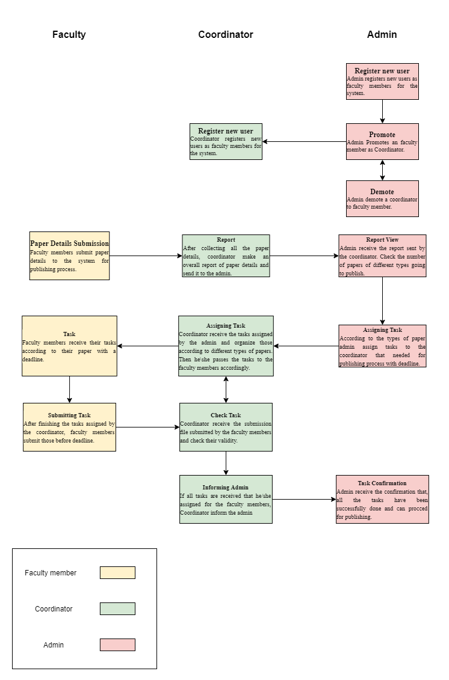

Figure 1.1: Block Diagram

* 1. **Project Schedule**
     1. **Gantt Chart**

Table 1.1: Gantt Chart

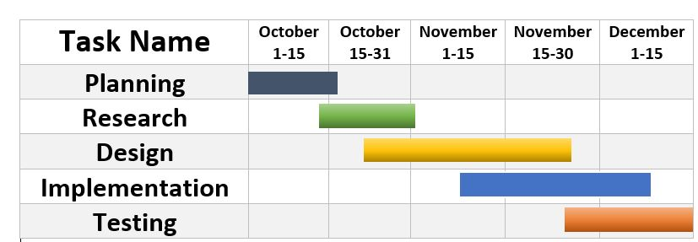

* + 1. **Release Plane/Milestone**

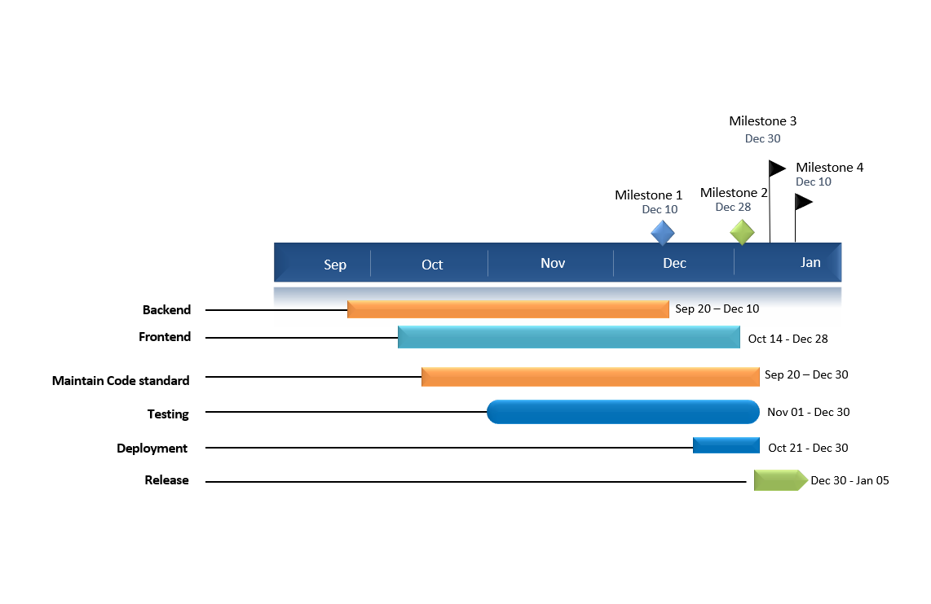

Figure 1.2: Milestone

**Chapter 2: Software Requirement Specification**

1. **Functional Requirements**

Functionality requirements refers to the functions included in the system to understand the functionality requirements application. If an application is created, then of course functional requirements are required. Here I am going to discuss the functional requirements of the “Research Coordinating System”.

* 1. **Log In**

Table 2.1: Log In

|  |  |  |  |
| --- | --- | --- | --- |
| **FR-1** | **Log In** | | |
| **Description** | Admin can log in to this system with his/her login credentials. After registered and promoted by the admin coordinator and faculty can also log in to this system with credentials. | | |
| **Stakeholders** | Admin, Coordinator, Faculty | **Priority** | High |

* 1. **Update Profile**

Table 2.2: Update Profile

|  |  |  |  |
| --- | --- | --- | --- |
| **FR-2** | **Update Profile** | | |
| **Description** | Users of this system can update his/her profile after he/she is logged in. | | |
| **Stakeholders** | Admin, Coordinator, Faculty | **Priority** | Low |

* 1. **Register New User**

Table 2.3: Register New User

|  |  |  |  |
| --- | --- | --- | --- |
| **FR-3** | **Register New User** | | |
| **Description** | Admin and Coordinator can register a new user for this system with necessary information. | | |
| **Stakeholders** | Admin, Coordinator | **Priority** | High |

* 1. **Assign Coordinator**

Table 2.4: Assign Coordinator

|  |  |  |  |
| --- | --- | --- | --- |
| **FR-4** | **Assign Coordinator** | | |
| **Description** | Admin can promote a faculty member as a coordinator. He/she can also demote a coordinator to faculty member. | | |
| **Stakeholders** | Admin | **Priority** | High |

* 1. **Assign Task**

Table 2.5: Assign Task

|  |  |  |  |
| --- | --- | --- | --- |
| **FR-5** | **Assign Task** | | |
| **Description** | Admin can assign tasks for coordinator and coordinator can assign task for faculty members. | | |
| **Stakeholders** | Admin, Coordinator | **Priority** | Medium |

* 1. **Submit Paper Details**

Table 2.6: Submit Paper Details

|  |  |  |  |
| --- | --- | --- | --- |
| **FR-6** | **Submit Paper Details** | | |
| **Description** | Faculty members can submit paper details about their research in the system they want to publish. | | |
| **Stakeholders** | Faculty | **Priority** | Medium |

* 1. **Report writing**

Table 2.7: Report Writing

|  |  |  |  |
| --- | --- | --- | --- |
| **FR-7** | **Report Writing** | | |
| **Description** | Coordinator can make a report of overall paper details based on category after all the faculty members submitted their paper details. | | |
| **Stakeholders** | Coordinator | **Priority** | Medium |

* 1. **Log Out**

Table 2.8: Log Out

|  |  |  |  |
| --- | --- | --- | --- |
| **FR-8** | **Log out** | | |
| **Description** | Users of this system can log out from the system. All the session records will be destroyed from the browser immediately. Users need to log in again in order to do something in the system. | | |
| **Stakeholders** | Admin, Coordinator, Faculty | **Priority** | High |

1. **Performance Requirements**

Performance requirements determine how effective the system is in a given situation. Examples include software response speed, throughput, execution time and storage capacity. Service levels with performance requirements often support end-user tasks.

* 1. **Speed and Latency Requirements**

System’s response time during working schedule is a major fact that specify an application’s quality. Overall response time of this system is good. Speed of a web application also depends on its host. It can be said that, with a good hosting facility the “Research Coordinating System” will work perfectly smooth and quick.

* 1. **Precision or Accuracy Requirements**

Accuracy of data provide by a system is mandatory for a good quality of system. This system provides 100% accurate data with the right authorization. In this system, I used unit of work for the surety of providing 100% accurate data. In this case if something goes wrong during collecting data from a user, the system will role back the whole process and the collecting process will start again for accuracy.

* 1. **Capacity Requirements**

Advanced systems must be able to manage user data, provide accurate information, manage databases, manage http requests.

Table 2.9: Capacity Requirements

|  |  |  |  |
| --- | --- | --- | --- |
| **CR-1** | **The system will handle more than thousands of data** | | |
| **Description** | The system needs to handle thousands of data every moment | | |
| **Stakeholders** | Admin, Coordinator, Faculty | **Priority** | High |

1. **Dependability Requirements**

Dependability is measured on the basis of four dimensions. Like:

* 1. **Reliability Requirements**

Table 2.10: Reliability Requirement

|  |  |  |  |
| --- | --- | --- | --- |
| **RR-1** | **The system will available 24*7** | | |
| **Description** | This system will give service to its user all day long, will be malware free and will be updated when needed. | | |
| **Stakeholders** | Admin, Coordinator, Faculty | **Priority** | Medium |

* 1. **Availability Requirements**

It is important to ensure a Zero percent crash to ensure error tolerance benefits for end users. It’s also mandatory to shows accurate results.

Table 2.11: Availability Requirement

|  |  |  |  |
| --- | --- | --- | --- |
| **AR-1** | **The system handles every user access without errors** | | |
| **Description** | It’s possible that all the user tries to log in or doing something in the system at a time. In this situation system must handle their request without system errors. | | |
| **Stakeholders** | N/A | **Priority** | Medium |

* 1. **Robustness or Fault-Tolerance Requirements**

Providing after service and support to the end user is very important.

* 1. **Safety-Critical Requirements**

Scalability requirements define specific scalability requirements for stakeholders. This system is designed for maintenance, avoiding single points of failure and supplying as much as necessary data.

1. **Security Requirements**

Software security requirements should be its functional requirement. Software protection implements the protection of an application. Software security related functionality can be either directly tested or monitored. Below are some safety requirements:

* A proper way of sign in.
* Sign in credentials shouldn’t be disclosed to anyone in any situation.
* Gaining access according to the user type.
* Proper control swapping in the time of promote and demote
* Denying unauthorized registration
* Clearing session properly as a user log out

When users access the system, each and every module must be supplied from the central authentication process.

* 1. **Access Requirements**

Table 2.12: Access Requirement

|  |  |  |  |
| --- | --- | --- | --- |
| **ACR-1** | **Application Provides Secure Log In System** | | |
| **Description** | Each and every step of the system designed in such a way that it only allows the authorized users. | | |
| **Stakeholders** | N/A | **Priority** | High |

* 1. **Integrity Requirements**

Integrity requirements refer to a security system that ensures data quality expectations. It also ensures that all data on the system is never exposed to malicious changes or unexpected destruction.

* 1. **Privacy Requirements**

Ensuring the privacy of system users is very important. To ensure privacy, the central database is protected by anonymity. Users are allowed access to the data they are authorized to use.

1. **Usability and Human-Interaction Requirements**

Systems may fail for usability. That’s shy I build this application very user friendly, easy to understand and easy to manage.

* 1. **Personalization and Internationalization Requirements**

There is no personalization and internationalization requirements.

* 1. **Understandability and Politeness Requirements**

This system is built for organizational use. The interface is designed in a way that is very easy to understand. There are diagrams to fully understand the systems main working mechanism.

* 1. **Accessibility Requirements**

This system is built for organizational use only. So, I prefer that only the registered users have the accessibility for the system. And no one can register himself. Only the admin and coordinator can register a user. Then the user will be a valid user for the system.

* 1. **User Documentation Requirements**

There is no user documentation required in the system.

* 1. **Training Requirements**

No training requirements needed for this system.

1. **Look and Feel Requirements**

If a system does not look structured, users feel annoyed and does not want to go further. There are requirements to see and feel what the system will look like and how the system’s user interface or graphical user interface will be displayed to users.

* 1. **Appearance Requirements**

The system is built in an understandable way that the users can easily use. For an example if admin added a task for coordinator, then the coordinator will be notified about his/her task. Accordingly, faculty members will be notified if coordinator add any task for them. Also, they can check if the task is completed by the users they appointed for. Users will understand the system very easily after they started working in it.

* 1. **Style Requirements**

Table 2.13: Style Requirement

|  |  |  |  |
| --- | --- | --- | --- |
| **SR-1** | **All content must be appearing within a format** | | |
| **Description** | Input field and other view result show a specific format | | |
| **Stakeholders** | Admin, Coordinator, Faculty | **Priority** | Medium |

1. **Operational and Environmental Requirements**

There are no operational and environmental requirements in this system.

1. **Legal Requirements**

There are no legal requirements in this system.

**Chapter 3: System Analysis**

1. **Use Case Diagram**

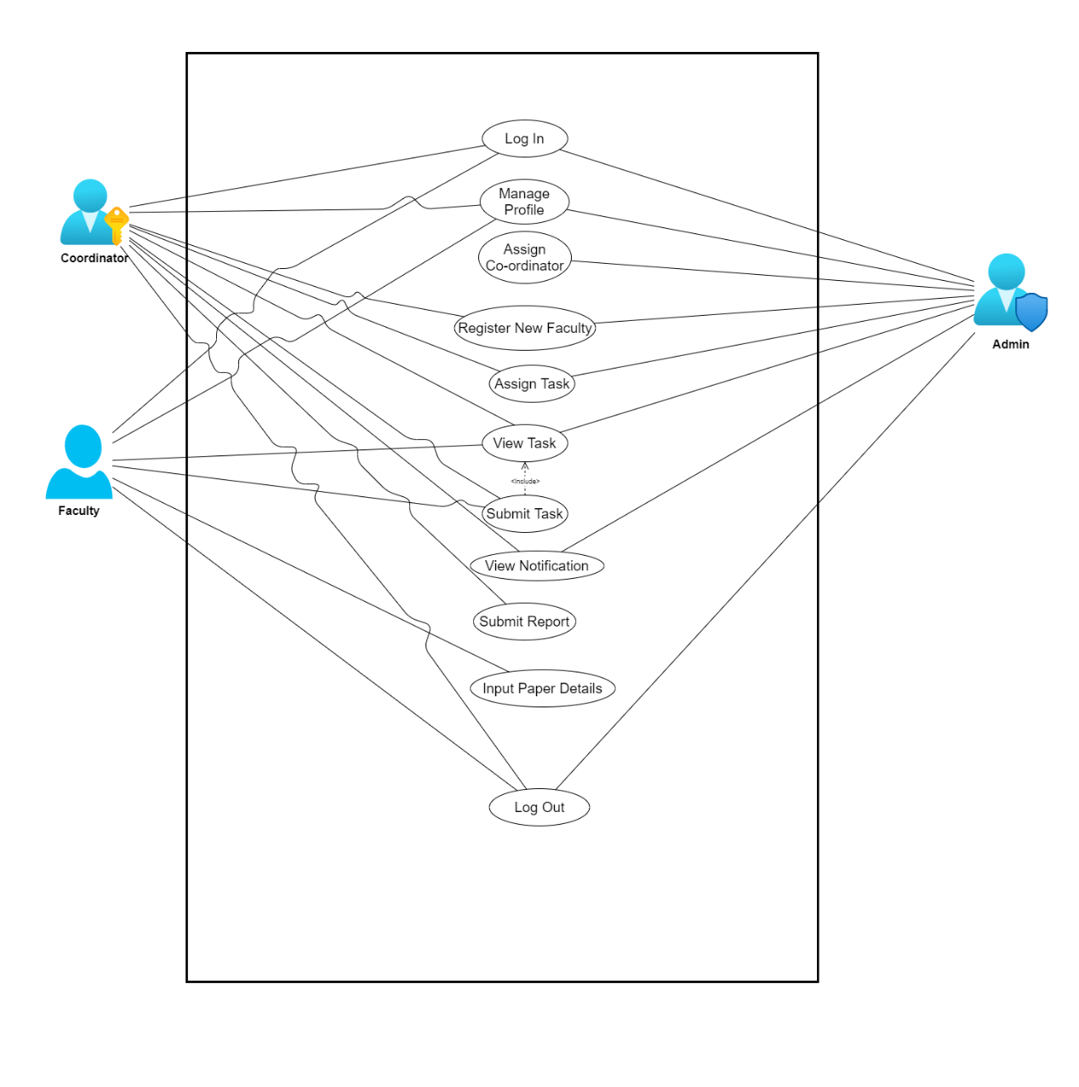

Figure 3.1: Use Case Diagram for “Research Coordinating System”

1. **Use Case Description**
   1. **Log In**

Table 3.1: Log In

|  |  |  |
| --- | --- | --- |
| **Use Case Title** | **Log In** | |
| **Goal** | Entering the dashboard according to user type | |
| **Preconditions** | Must be a registered user | |
| **Success End Condition** | Successfully logged in to dashboard | |
| **Failure End Condition** | Incorrect Email or Password | |
| **Primary Actor:**  **Secondary Actor:** | User  System | |
| **Trigger** | Log in button | |
| **Description**  **Main Success Scenario** | **Step** | **Action** |
| 1 | User Input log in credentials |
| 2 | Log in successful to dashboard |
| 3 | User can use his/her dedicated work flows |
| **Alternative flows** | **Step** | **Branching Action** |
| 1 | Input incorrect or unregistered data |
| 2 | Log in failed due to incorrect credentials |
| **Quality Requirements** | **Step** | **Requirements** |
|  | N/A |

* 1. **Manage Profile**

Table 3.2: Manage Profile

|  |  |  |
| --- | --- | --- |
| **Use Case Title** | **Manage Profile** | |
| **Goal** | Updating Name or adding phone number | |
| **Preconditions** | Must be a logged in | |
| **Success End Condition** | Well formatted data for required field | |
| **Failure End Condition** | Using bad formatted data for required field | |
| **Primary Actor:**  **Secondary Actor:** | User  System | |
| **Trigger** | Edit Profile Menu | |
| **Description**  **Main Success Scenario** | **Step** | **Action** |
| 1 | User click edit profile |
| 2 | User serve needed information |
| 3 | Profile updated |
| **Alternative flows** | **Step** | **Branching Action** |
| 1 | Input incorrect information |
| 2 | Update failed |
| **Quality Requirements** | **Step** | **Requirements** |
|  | N/A |

* 1. **Assign Coordinator**

Table 3.3: Coordinator Assign

|  |  |  |
| --- | --- | --- |
| **Use Case Title** | **Assign Coordinator** | |
| **Goal** | Promoting a Faculty member as a Coordinator | |
| **Preconditions** | Must be logged in as an admin | |
| **Success End Condition** | The targeted user must be a registered faculty member | |
| **Failure End Condition** | The targeted user is already a Coordinator or an Admin or is not registered yet | |
| **Primary Actor:**  **Secondary Actor:** | Admin  Faculty | |
| **Trigger** | Assign Coordinator Menu | |
| **Description**  **Main Success Scenario** | **Step** | **Action** |
| 1 | User must be an Admin |
| 2 | Target the user needed to assign as Coordinator |
| 3 | Click on Edit role and select Coordinator |
| **Alternative flows** | **Step** | **Branching Action** |
| 1 | Selecting Faculty again instead of Coordinator |
| 2 | Targeting a Coordinator for assigning as coordinator |
| **Quality Requirements** | **Step** | **Requirements** |
|  | N/A |

* 1. **Register New Faculty**

Table 3.4: Register New Faculty

|  |  |  |
| --- | --- | --- |
| **Use Case Title** | **Register New Faculty** | |
| **Goal** | Adding a user as faculty member in the system | |
| **Preconditions** | Must be logged in as Coordinator or Admin | |
| **Success End Condition** | Serving valid information to the system | |
| **Failure End Condition** | Serving invalid information to the system | |
| **Primary Actor:**  **Secondary Actor:** | Admin, Coordinator  Faculty | |
| **Trigger** | Register New Faculty from Menu | |
| **Description**  **Main Success Scenario** | **Step** | **Action** |
| 1 | Logged in as Coordinator or Admin |
| 2 | Supplying valid information |
| 3 | Registered user successfully |
| **Alternative flows** | **Step** | **Branching Action** |
| 1 | Supplying invalid information |
| 2 | Incorrect information causes registration failure |
| **Quality Requirements** | **Step** | **Requirements** |
|  | N/A |

* 1. **Assign Task**

Table 3.5: Assig Task

|  |  |  |
| --- | --- | --- |
| **Use Case Title** | **Assign Task** | |
| **Goal** | Assigning task for the coordinator and faculty to progressing the publishing process | |
| **Preconditions** | Logged in as Admin or Coordinator | |
| **Success End Condition** | Providing valid information about task | |
| **Failure End Condition** | Providing invalid information about task | |
| **Primary Actor:**  **Secondary Actor:** | Admin, Coordinator  Faculty | |
| **Trigger** | Task from the side menu | |
| **Description**  **Main Success Scenario** | **Step** | **Action** |
| 1 | Providing task including needed information |
| 2 | Selecting candidate for this task |
| 3 | Select deadline for the task |
| **Alternative flows** | **Step** | **Branching Action** |
| 1 | Incomplete information about task |
| 2 | Task couldn’t be assigned |
| **Quality Requirements** | **Step** | **Requirements** |
|  | N/A |

* 1. **View Task**

Table 3.6: View Task

|  |  |  |
| --- | --- | --- |
| **Use Case Title** | **View Task** | |
| **Goal** | View tasks that assigned by the user and for the user | |
| **Preconditions** | Must be a registered user | |
| **Success End Condition** | Tasks must be assigned | |
| **Failure End Condition** | No tasks assigned | |
| **Primary Actor:**  **Secondary Actor:** | Coordinator, Faculty  Admin, Coordinator | |
| **Trigger** | Task from side menu | |
| **Description**  **Main Success Scenario** | **Step** | **Action** |
| 1 | Click task menu from side menu bar |
| 2 | View tasks assigned for me and assigned by me |
| 3 | Click on the specific one to view details |
| **Alternative flows** | **Step** | **Branching Action** |
| 1 | Request for view tasks |
| 2 | No task assigned |
| **Quality Requirements** | **Step** | **Requirements** |
|  | N/A |

* 1. **Submit Task**

Table 3.7: Submit Task

|  |  |  |
| --- | --- | --- |
| **Use Case Title** | **Submit Task** | |
| **Goal** | Submit the assigned task before deadline | |
| **Preconditions** | Logged in and tasks must be assigned | |
| **Success End Condition** | Tasks submitted successfully | |
| **Failure End Condition** | Tasks is not submitted | |
| **Primary Actor:**  **Secondary Actor:** | Coordinator, Faculty  Admin, Coordinator | |
| **Trigger** | Task from side menu bar | |
| **Description**  **Main Success Scenario** | **Step** | **Action** |
| 1 | Select the task that need to be submitted |
| 2 | Upload the file that contains submission content |
| 3 | Assigner receive the file successfully |
| **Alternative flows** | **Step** | **Branching Action** |
| 1 | Submitting without content file |
| 2 | Submitting file without any content |
| **Quality Requirements** | **Step** | **Requirements** |
|  | N/A |

* 1. **View Notification**

Table 3.8: View Notification

|  |  |  |
| --- | --- | --- |
| **Use Case Title** | **View Notification** | |
| **Goal** | Alert about deadlines and tasks assigned | |
| **Preconditions** | Must be logged in | |
| **Success End Condition** | Nearby deadline or new task assigned for the user | |
| **Failure End Condition** | No tasks available for the user | |
| **Primary Actor:**  **Secondary Actor:** | Users  System | |
| **Trigger** | Notification from side menu bar | |
| **Description**  **Main Success Scenario** | **Step** | **Action** |
| 1 | User check the notification menu |
| 2 | Notification menu shows the nearby deadlines and new tasks assigned for the user |
| 3 | Select specific notification to complete it |
| **Alternative flows** | **Step** | **Branching Action** |
| 1 | No tasks available for the user |
| 2 | Notification window contain nothing |
| **Quality Requirements** | **Step** | **Requirements** |
|  | N/A |

* 1. **Submit Report**

Table 3.9: Submit Report

|  |  |  |
| --- | --- | --- |
| **Use Case Title** | **Submit Report** | |
| **Goal** | Informing admin about research papers going to publish according to category | |
| **Preconditions** | Must be logged in as Coordinator | |
| **Success End Condition** | All the paper details must be submitted before making report | |
| **Failure End Condition** | Making report before submitting paper details | |
| **Primary Actor:**  **Secondary Actor:** | Coordinator  Admin | |
| **Trigger** | Report writing from side menu bar | |
| **Description**  **Main Success Scenario** | **Step** | **Action** |
| 1 | Coordinator request for report |
| 2 | System categorify all paper details |
| 3 | Coordinator passes the report to the admin |
| **Alternative flows** | **Step** | **Branching Action** |
| 1 | Coordinator request for report before all paper details have been submitted |
| 2 | Invalid informational report created |
| **Quality Requirements** | **Step** | **Requirements** |
|  | N/A |

* 1. **Input Paper Details**

Table 3.10: Input Paper Details

|  |  |  |
| --- | --- | --- |
| **Use Case Title** | **Input Paper Details** | |
| **Goal** | Providing information about the research papers going to publish | |
| **Preconditions** | Logged in as faculty members | |
| **Success End Condition** | Providing valid information in the required fields | |
| **Failure End Condition** | Providing invalid information or Existing information | |
| **Primary Actor:**  **Secondary Actor:** | Faculty  Coordinator | |
| **Trigger** | Paper Details from the side menu bar | |
| **Description**  **Main Success Scenario** | **Step** | **Action** |
| 1 | Faculty input a paper detail |
| 2 | Submit the details for review |
| 3 | Coordinator receive the details |
| **Alternative flows** | **Step** | **Branching Action** |
| 1 | Faculty input an existing detail |
| 2 | System reject the submission |
| **Quality Requirements** | **Step** | **Requirements** |
|  | N/A |

* 1. **Log Out**

Table 3.11: Log Out

|  |  |  |
| --- | --- | --- |
| **Use Case Title** | **Log Out** | |
| **Goal** | Exit the system | |
| **Preconditions** | Must be logged in | |
| **Success End Condition** | User is logged in | |
| **Failure End Condition** | User is already logged out | |
| **Primary Actor:**  **Secondary Actor:** | User  System | |
| **Trigger** | Log out button | |
| **Description**  **Main Success Scenario** | **Step** | **Action** |
| 1 | User completed his/her work on system |
| 2 | User clicked log out button |
| 3 | System logged out the user and clear his/her session records |
| **Alternative flows** | **Step** | **Branching Action** |
| 1 | User close the browser instead of log out |
| 2 | System will catch his/her session record for a defined time for that browser. Then it will be cleaned also. |
| **Quality Requirements** | **Step** | **Requirements** |
|  | N/A |

1. **Activity Diagram**
   1. **Activity Diagram (Log In)**

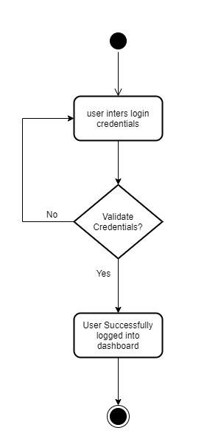

Figure 3.2: Activity Diagram for Log in

* 1. **Activity Diagram (Manage Profile)**

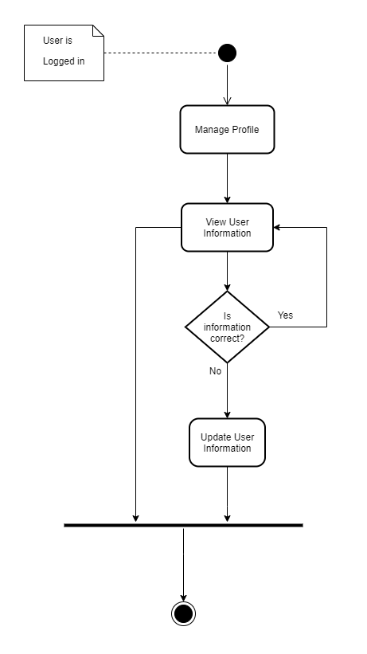

Figure 3.3: Activity diagram for Manage Profile

* 1. **Activity Diagram (Assign Coordinator)**

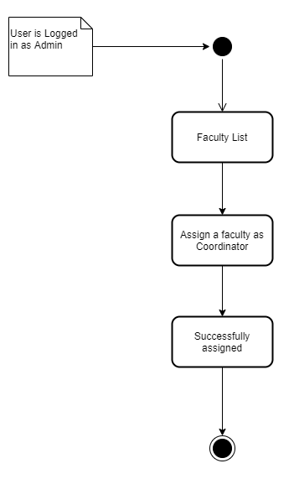

Figure 3.4: Activity diagram for Assign Coordinator

* 1. **Activity Diagram (Register New Faculty)**

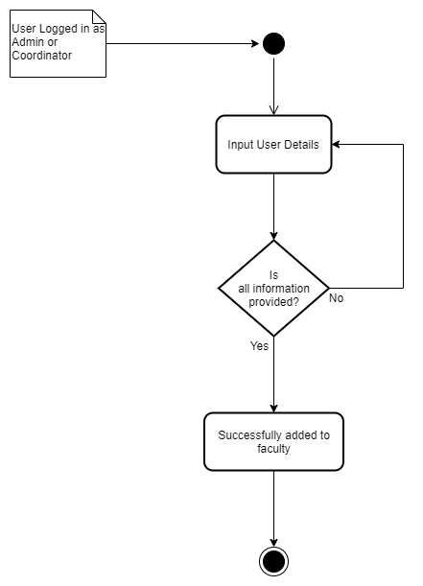

Figure 3.5: Activity diagram for Register New Faculty

* 1. **Activity Diagram (Assign Task)**

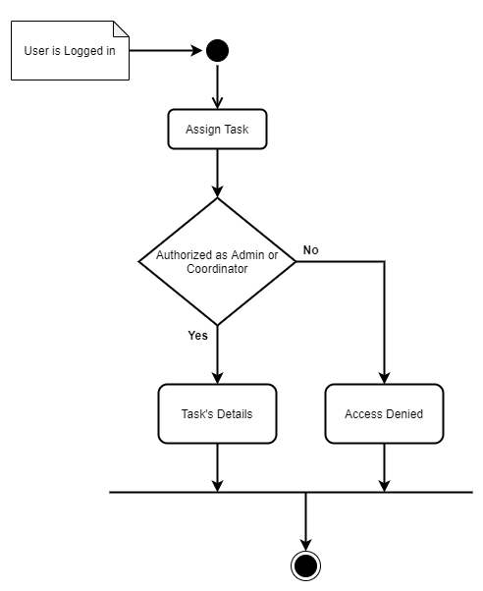

Figure 3.6: Activity diagram for Assign Task

* 1. **Activity Diagram (view Task)**

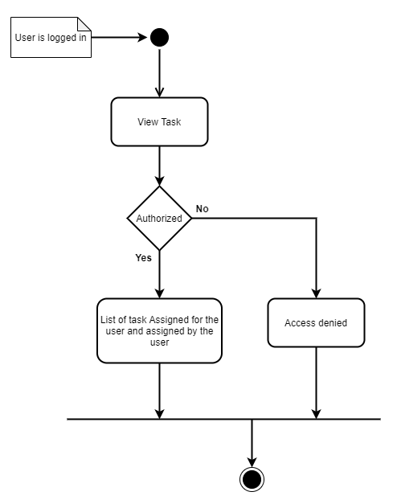

Figure 3.7: Activity diagram for View Task

* 1. **Activity Diagram (Submit Task)**

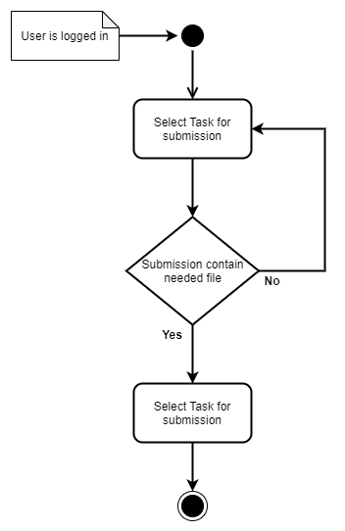

Figure 3.8: Activity diagram for Submit Task

* 1. **Activity Diagram (View Notification)**

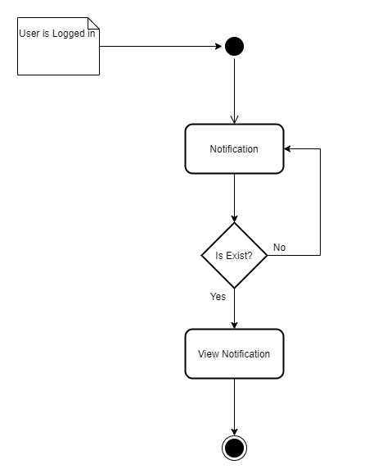

Figure 3.9: Activity diagram for Notification

* 1. **Activity Diagram (Report Writing)**

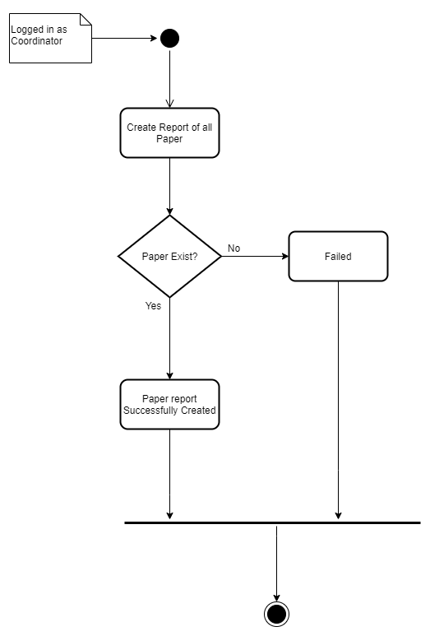

Figure 3.10: Activity diagram for Report Writing

* 1. **Activity Diagram (Input Paper Details)**

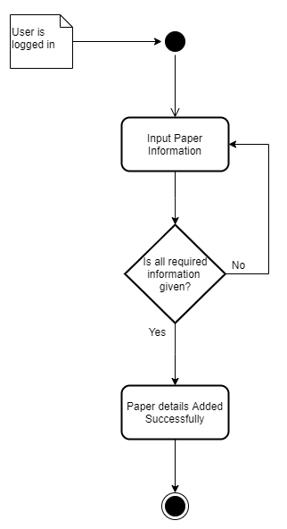

Figure 3.11: Activity diagram for Paper Details

* 1. **Activity Diagram (Log Out)**

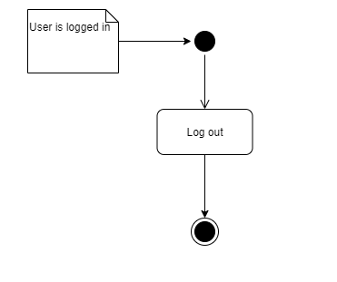

Figure 3.12: Activity diagram for Log Out

1. **System Sequence Diagram**
   1. **Sequence Diagram (Log In)**

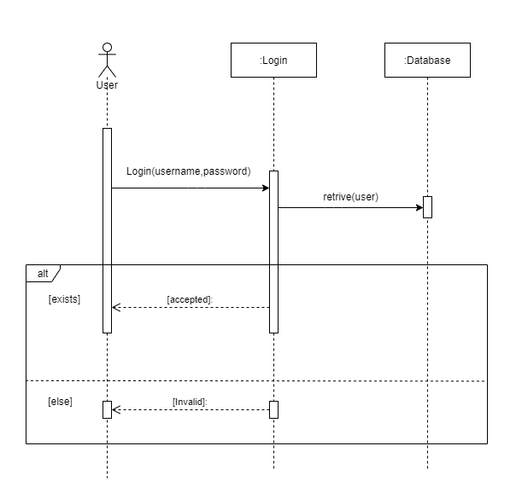

Figure 3.13: Sequence diagram for Log in

* 1. **Sequence Diagram (Manage Profile)**

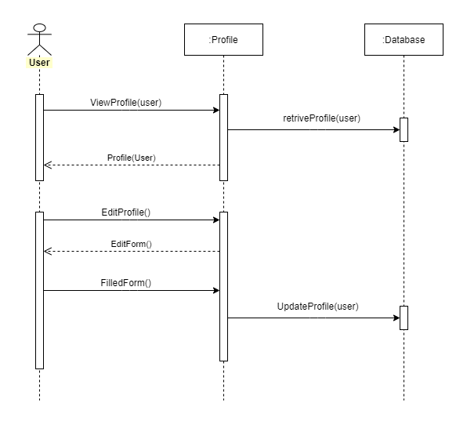

Figure 3.14: Sequence diagram for Manage Profile

* 1. **Sequence Diagram (Assign Coordinator)**

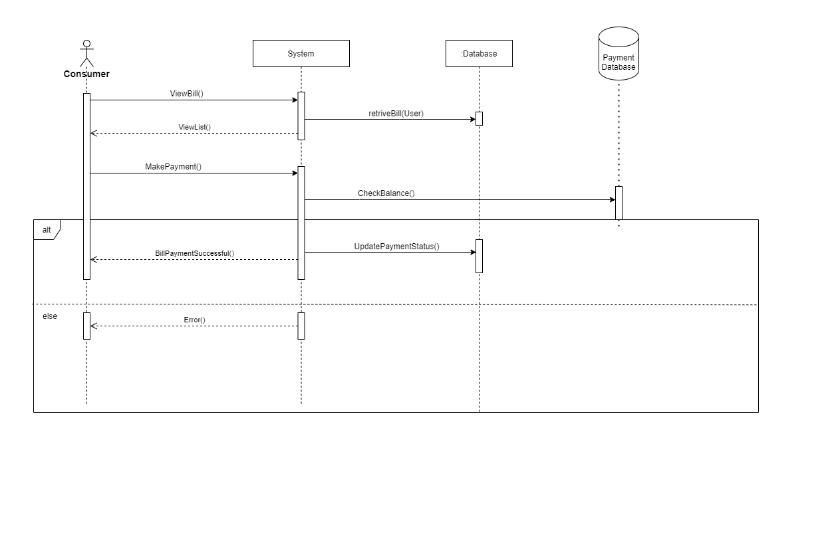

Figure 3.15: Sequence diagram for Assign Coordinator

* 1. **Sequence Diagram (Register New Faculty)**

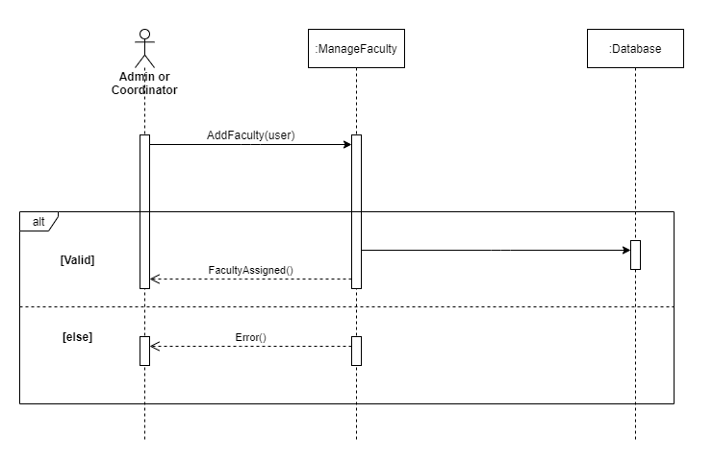

Figure 3.16: Sequence diagram for Register New User

* 1. **Sequence Diagram (Assign Task)**

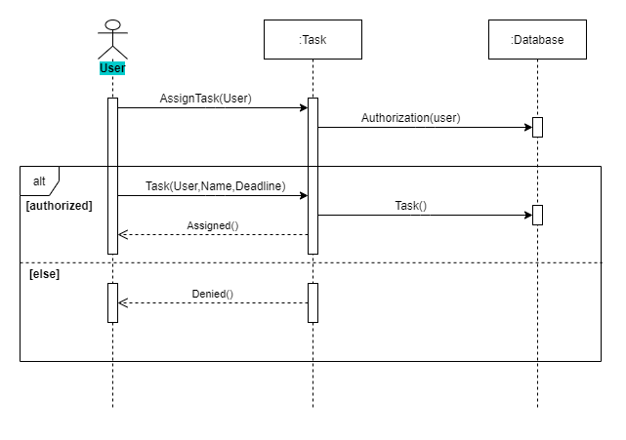

Figure 3.17: Sequence diagram for Assign Task

* 1. **Sequence Diagram (View Task)**

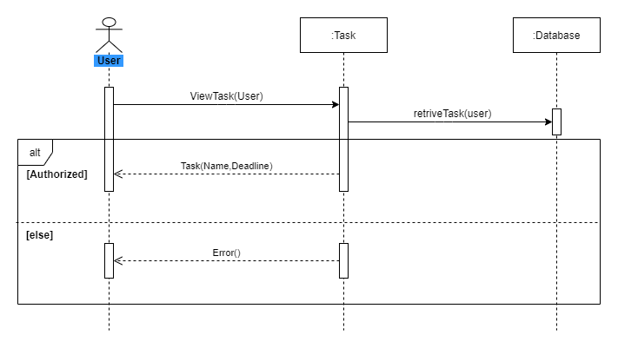

Figure 3.18: Sequence diagram for View Task

* 1. **Sequence Diagram (Submit Task)**

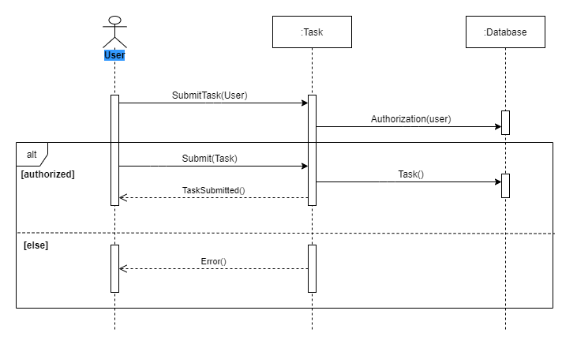

Figure 3.19: Sequence diagram for Submit Task

* 1. **Sequence Diagram (View Notification)**

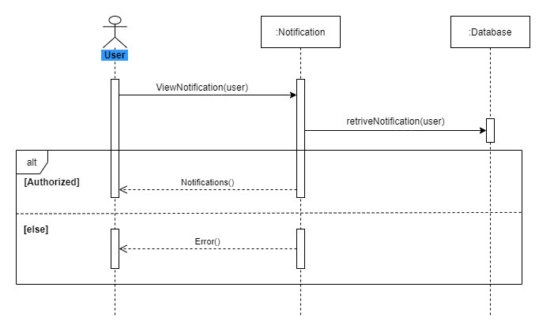

Figure 3.20: Sequence diagram for View Notification

* 1. **Sequence Diagram (Report Writing)**

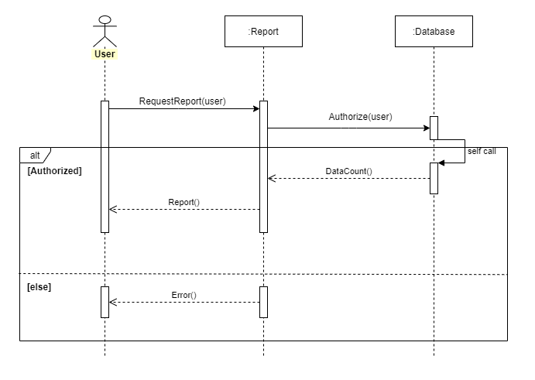

Figure 3.21: Sequence diagram for Report Writing

* 1. **Sequence Diagram (Input Paper Details)**

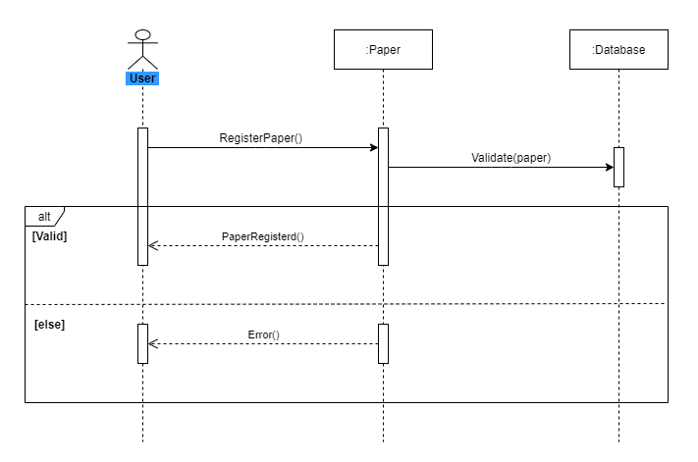

Figure 3.22: Sequence diagram for Input Paper Details

* 1. **Sequence Diagram (Log Out)**

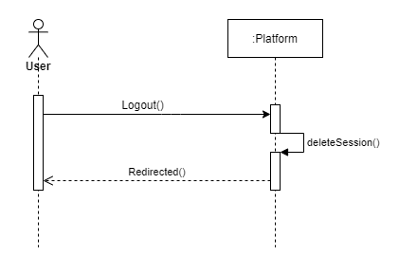

Figure 3.23: Sequence diagram for Log Out

**Chapter 4: System Design Specification**

1. **Class Responsibilities Collaboration (CRC) Cards**

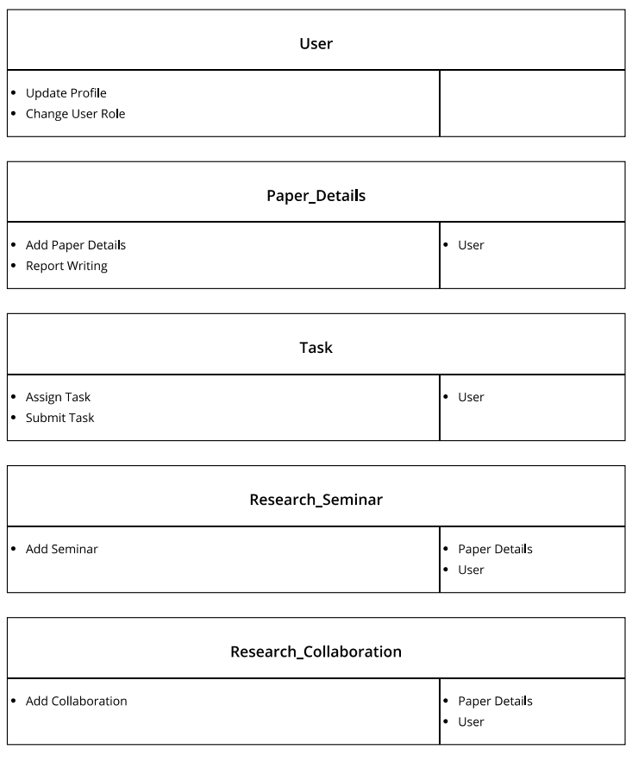

Figure 4.1: CRC cards for “Research Coordinating System”

1. **Class Diagram**

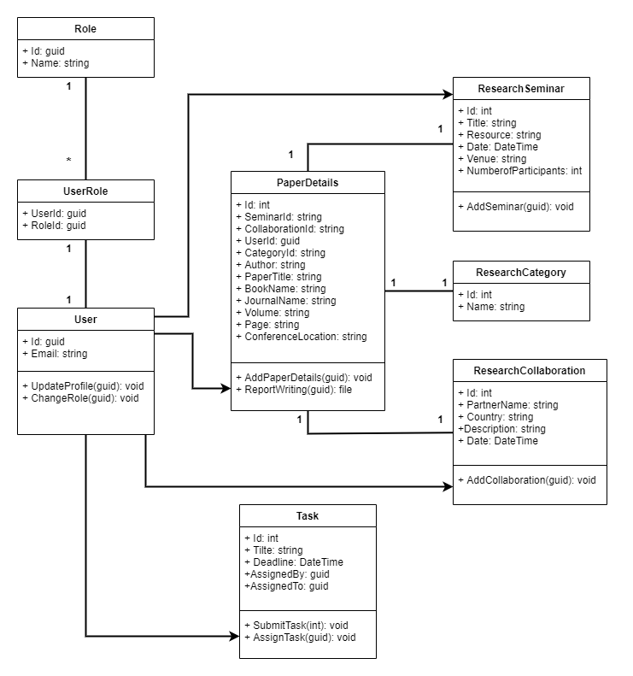

Figure 4.2: Class Diagram for “Research Coordinating System”

1. **Database Design Diagram**

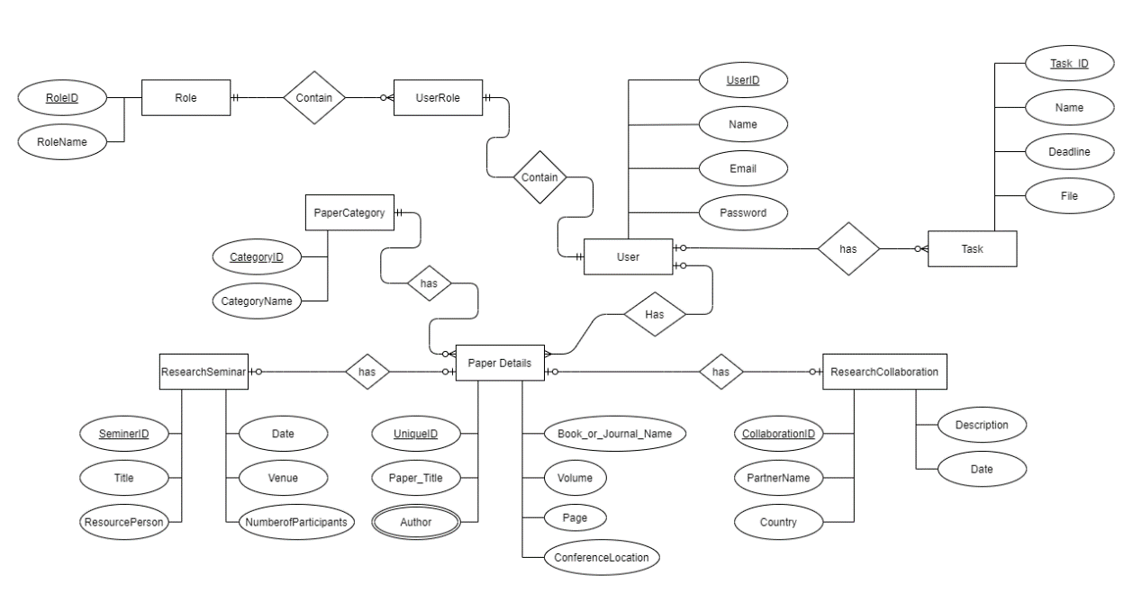

Figure 4.3: Database Design Diagram

1. **Development Tools & Technology**

For developing a quality software, development tools are used. Various development tools like programming tools, debugging tools, testing tools and so on are used to develop different types of applications. For the “Research Coordinating System” web application I also use those types of tools and technologies. They are:

* 1. **User Interface Technology**

The user interface means the visual part of a software. This interface has been created following the needs of the users so that they can easily interact with the system. The ultimate goal of the user interface is to deploy the user to the system. A good user interface makes an application effective, reliable and efficient.

* + 1. **ASP.NET MVC Framework**

For the “Research Coordinating System” web-based application, the ASP.NET MVC framework is used. Security is a valuable part of web-based applications. ASP.NET offers more secure than many other frameworks. MVC (Model View Controller) is also a good architecture for web-based systems.

* + 1. **jQuery**

In this system, ajax jQuery is used to retrieve data from dB context to datatables in user interface. It makes the data more effective and usable. It also decreases the retrieve time.

* + 1. **CSS Framework and Bootstrap**

CSS means “Cascading Style Sheets”. It helps the html elements to appear in a good-looking way. Bootstrap makes our web-application responsive. It’s a free and open-source framework. Bootstrap is also used in the “Research Coordinating System” application so that the layout matches the variety screen size easily.

* 1. **Implementation Tools & Platforms**

Selecting the tools and platforms applied is also an important factor in getting the application done properly. Anyone who wants to apply must analyze which equipment and platform is appropriate with the system. So, another challenge for the developer is to find the best tools to optimize his/her application.

* + 1. **Microsoft Visual Studio 2019**

A code editor or IDE is required to develop an application system. An IDE is used to edit the source code of applications. My used IDE for this project is Microsoft Visual Studio 2019. The community version is free and it has many great features to standardized source code for any application.

* + 1. **MSSQL Server 2018**

MSSQL server is used in this application as database server. Database server refers to the back-end system of a database application. MSSQL server is free, easy to use and it also maintain security angles.

* + 1. **.NET Runtime**

CLR (Common Language Runtime) is an application virtual machine that provides services like protection, memory management and exception handling. .NET runtime is free CLR by Microsoft. The latest version is cross platform.

**Chapter 5: System Testing**

1. **Testing Features**
   1. **Features to be tested**

* Log in
* Register new faculty
* Assigning Coordinator
* Adding paper details
* Assigning task
  1. **Features not to be tested**

1. **Testing Strategies**
   1. **Unit Testing**

Unit is the smallest testable part of an application like function, classes, procedures, interfaces. Unit testing is created and executed by software developer during the development process.

* **Log in**

Table 5.1: Log in

|  |  |
| --- | --- |
| Test case: TC001 | Test designed by: Sabbir |
| Test priority: High | Test design date: 01-12-2020 |
| Model name: Log in | Test executed by: Sabbir |
| Description: User can log in to the system with valid credentials. | Test execute date: 01-12-2020 |

* **Register New Faculty**

Table 5.2: Register New Faculty

|  |  |
| --- | --- |
| Test case: TC002 | Test designed by: Sabbir |
| Test priority: High | Test design date: 01-12-2020 |
| Model name: Register new faculty | Test executed by: Sabbir |
| Description: Registration process done by the admin or coordinator. | Test execute date: 01-12-2020 |

* **Assigning Coordinator**

Table 5.3: Assigning Coordinator

|  |  |
| --- | --- |
| Test case: TC003 | Test designed by: Sabbir |
| Test priority: High | Test design date: 01-12-2020 |
| Model name: Assign coordinator | Test executed by: Sabbir |
| Description: Admin assign a faculty member as coordinator. | Test execute date: 01-12-2020 |

* **Adding Paper details**

Table 5.4: Adding Paper Details

|  |  |
| --- | --- |
| Test case: TC004 | Test designed by: Sabbir |
| Test priority: Medium | Test design date: 01-12-2020 |
| Model name: Add paper details | Test executed by: Sabbir |
| Description: Faculty members add paper details they want to publish. | Test execute date: 01-12-2020 |

* **Assigning Task**

Table 5.5: Assign Task

|  |  |
| --- | --- |
| Test case: TC005 | Test designed by: Sabbir |
| Test priority: Medium | Test design date: 01-12-2020 |
| Model name: Task | Test executed by: Sabbir |
| Description: Admin and Coordinator assign task for the progress. | Test execute date: 01-12-2020 |

**Chapter 6: User Manual**

1. **User Manual (Admin)**
   1. **Admin Dashboard**

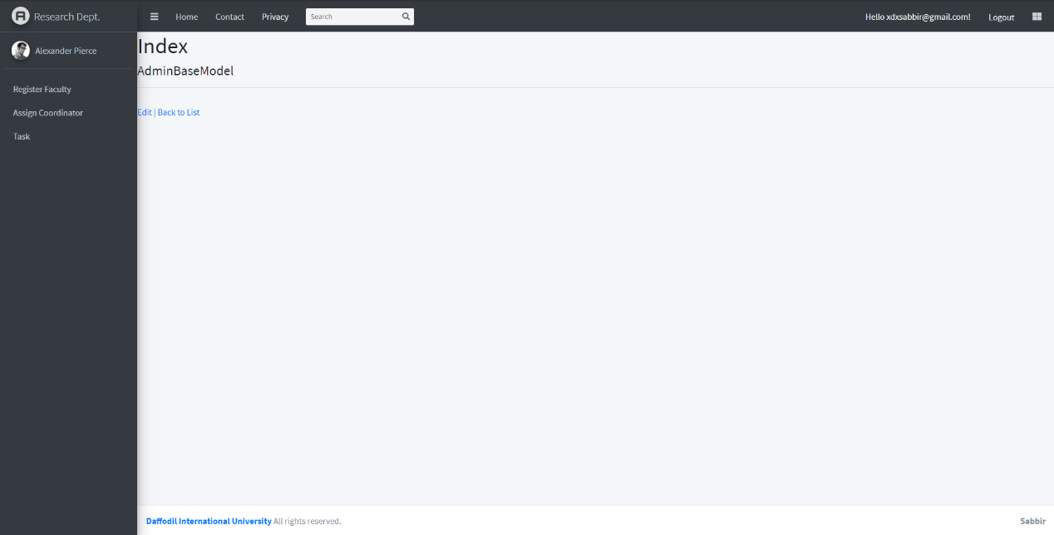

Figure 6.1: Admin Dashboard

* 1. **Register New User**

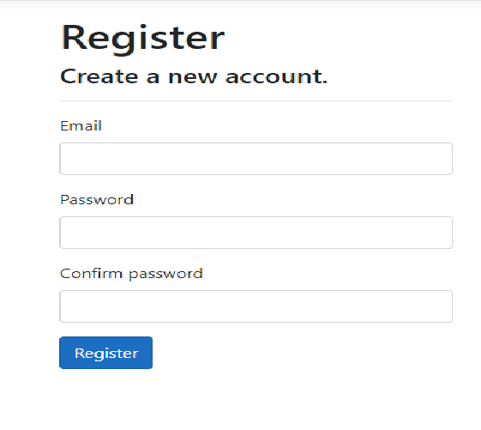

Figure 6.2: Register new faculty

* 1. **Assign Coordinator**

1. **User Manual (Coordinator)**
   1. **Dashboard**

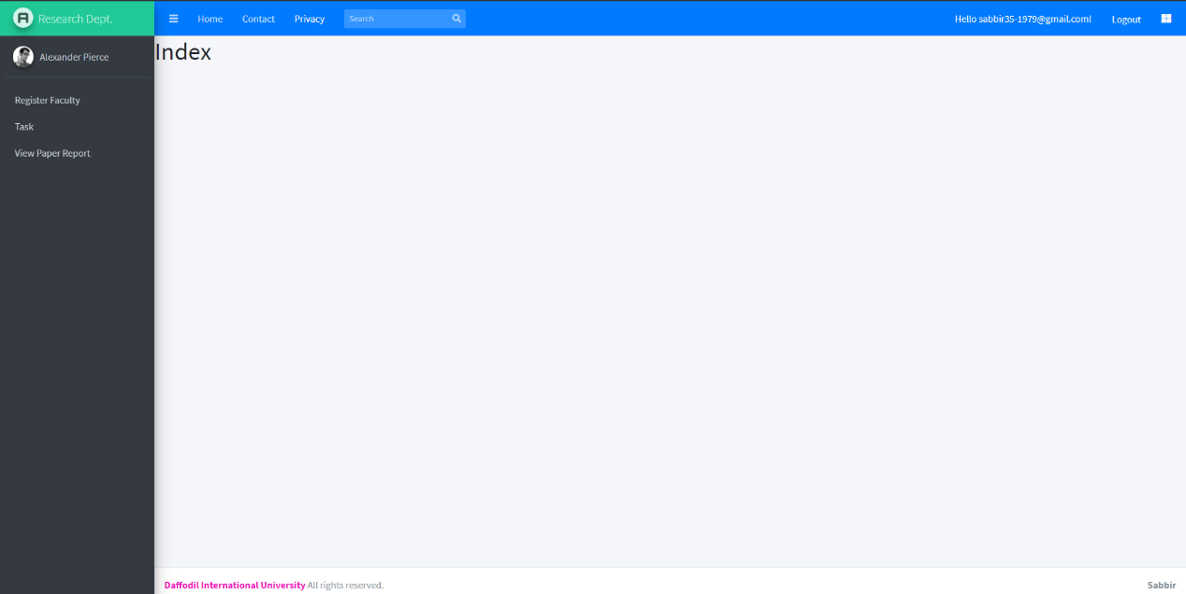

Figure 6.4: Coordinator Dashboard

* 1. **Register New Faculty**



Figure 6.5: Register New Faculty

* 1. **Report Writing**

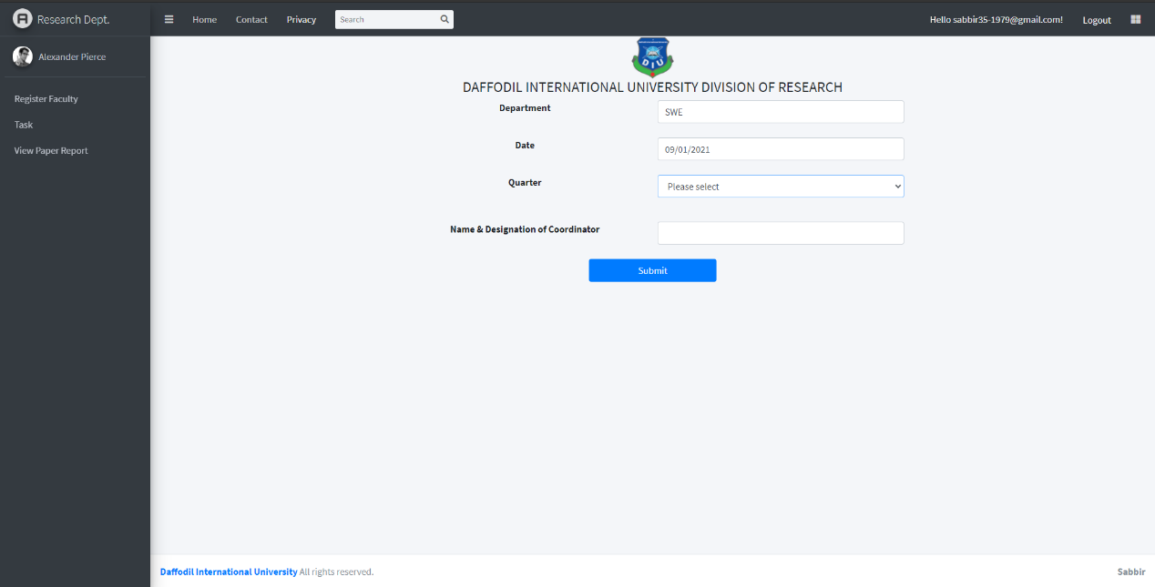

Figure 6.6: Report writing

1. **User Manual (Faculty)**
   1. **Dashboard**

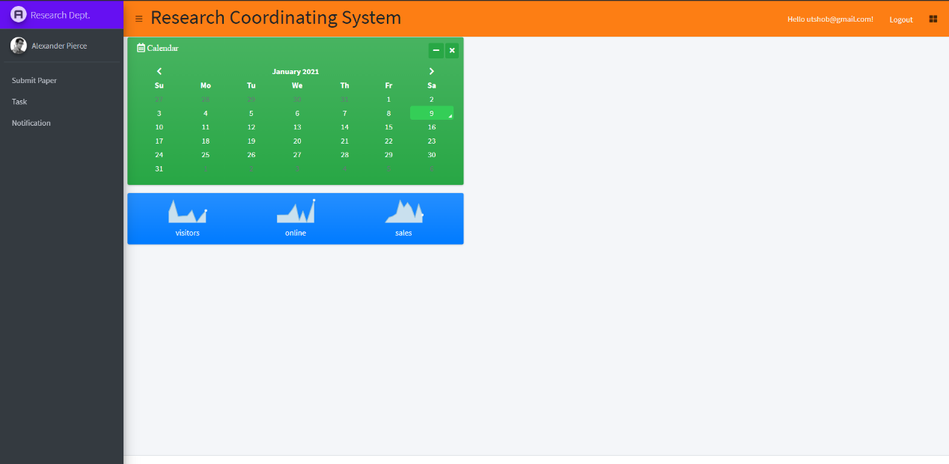

Figure 6.7: Faculty Dashboard

* 1. **Paper Details Submission**

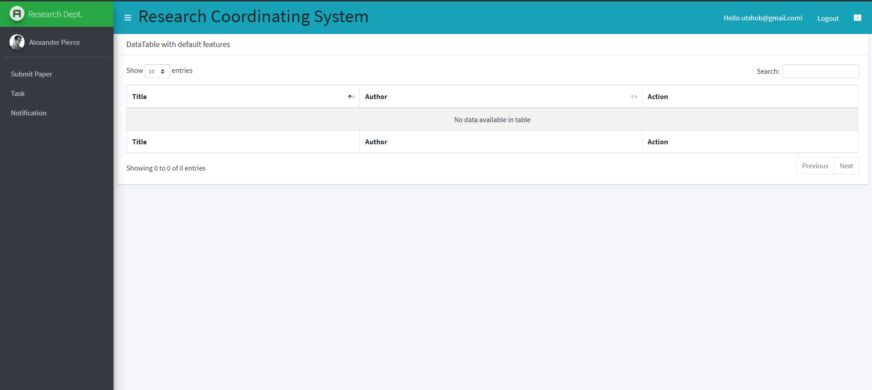

Figure 6.8: Paper Details Submission and submitted

* 1. **Tasks assigned**

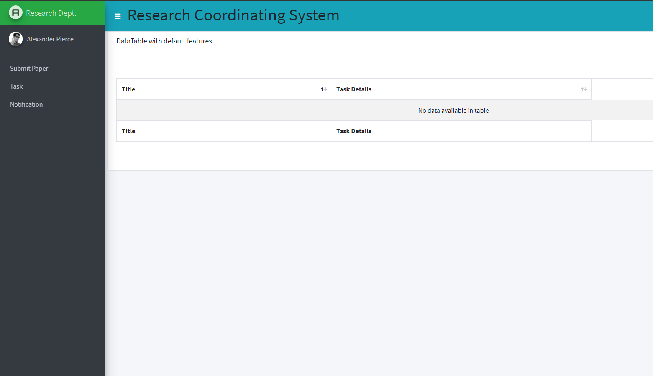

Figure 6.9: Tasks

**Chapter 7: Project Summary**

1. **GitHub Link**

<https://github.com/I-am-Sabbir/Research_Coordinating_System>

1. **Limitations**

Every application has some limitations as does this application.

* Notification alert can’t see at real time.
* Editing profile is limited.
* Mobile verification hasn’t set yet.

1. **Future Scope**

* More user-friendly frontend design.
* Overcome the limitations
* Connect worldwide departments with dynamic design

**Chapter 8: References**

1. **Documentation Idea:**

Thomas T. Barker, (1998). Writing Software Documentation. Retrieved from <https://cutt.ly/djMAyO3>

1. **System Requirement Specification:**

Andreas Rüping, ISBN: 978-0-470-85617-8, (September 11, 2003). *Agile Documentation: A Pattern Guide to Producing Lightweight Documents for Software Projects* (1st Chapter, Topic-19, P-(26-28)). Retrieved from <https://cutt.ly/ajMSGj2>

1. **Structure and Architecture:**

Luke Hohmann, (2003). Beyond Software Architecture. Retrieved from <https://cutt.ly/2jMDe8U>

1. **Unified Modeling Language:**

Luke Hohmann, (2003). Beyond Software Architecture. Retrieved from <https://cutt.ly/2jMDe8U>

1. **Testing:**

Paul C. Jorgensen, ISBN: 9781138628076, (November 28, 2013- by Auerbach Publications). *Software Testing: A Craftsman’s Approach, Fourth Edition 4th Edition* (Part-3, Beyond Unit Testing, P-(207-219)). Retrieved from <https://cutt.ly/JjMDAXS>

1. **Tools and Technologies:**

**Diagrams and Design:** <https://app.diagrams.net/>

**Articles:** [**https://cutt.ly/CjMD2c7**](https://cutt.ly/CjMD2c7)

